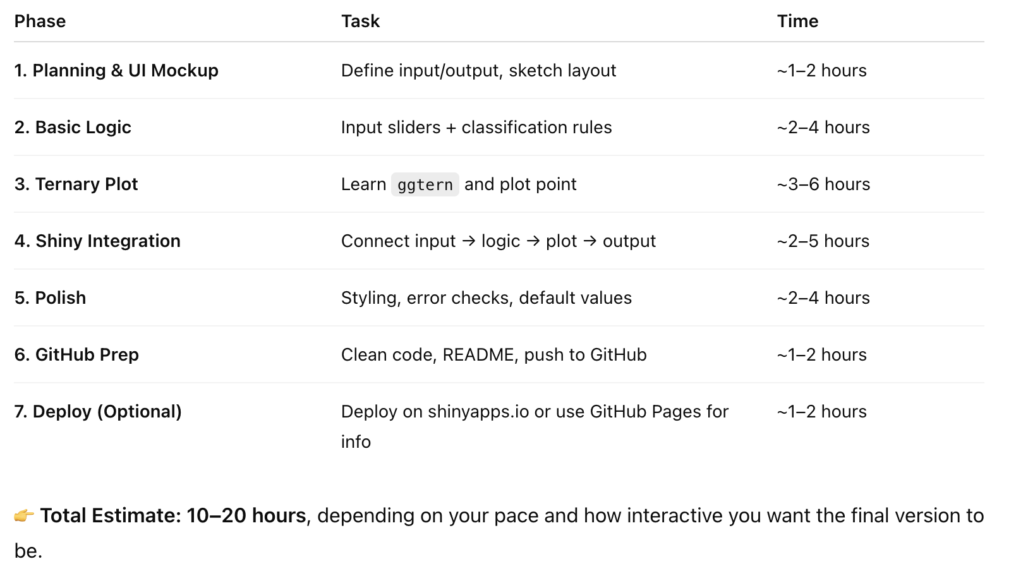

Wentworth grade scale

gravel-sized particles have a nominal diameter of ⩾2.0 mm;

sand-sized particles have nominal diameters from <2.0 mm to ⩾62.5 μm;

silt-sized particles have nominal diameters from <62.5 to ⩾4.0 μm; and

clay is <4.0 μm

Shepard (1954)